United Reformed Church South Western Synod Information Sheet 8

ENERGY PERFORMANCE CERTIFICATES

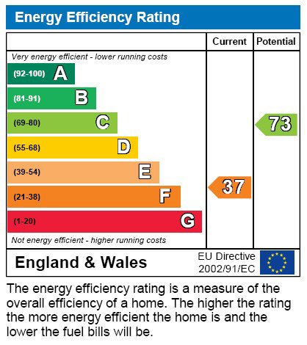

Your church may be affected if:

- Letting buildings or rooms
- Changing the occupation of a residence
- Constructing new buildings

What are Energy Peformance
Certificates (EPCs)
EPCs are the result of an European measure to reduce
energy consumption and CO2 emissions from buildings.
The certificate provides an energy efficiency rating primarily in the form of a bar-chart indicating the current level of energy efficiency and potential for improvement. Most property built, sold or being let requires an EPC, which is valid for 10 years. Certificates are issued by accredited assessors and are relatively inexpensive.

Churches and Church Buildings
Registered Places of Worship and Listed Buildings are exempt so for most churches there is no need to obtain an EPC, unless you want to. Church halls and meeting rooms which are shared or occupied under a licence will not require an EPC. However, where premises (or parts of premises) are leased with exclusive occupation a valid EPC will be required.

Manses and let property
The position for manses occupied by Ministers is not clear and if in doubt it is best to obtain an EPC. Where manses are let a valid EPC will be required, and the letting agent will be able to advise. A minimum EPC current rating of E or higher must be reached before the property can be let.
Although the EPC regulation does not apply to manses that have serving ministers resident, the Trust believes that all manses should be bought up to a standard of C or above. All newly purchased manses have a minimum level of C.

EPCs are required for all leases and licences (not hiring) from the 1 April 2023, when this requirement will tighten so that all tenanted commercial properties will have to achieve an E rating or less on their EPC, regardless of whether the tenancy is new. Looking further ahead, landlords also need to be aware of future proposals for the minimum standard to be increased to band ‘C’ by 1 April 2027 and band ‘B’ by 1 April 2030, although this is subject to change.
Much like the multi-coloured sticker on new appliances, Energy Performance Certificates (EPCs) tell you how energy efficient a building is and gives it a rating from A (very efficient) to G (inefficient). They’ll tell you how costly it will be to heat and light your property, and what its carbon dioxide emissions are likely to be.
An EPC also includes information on what the energy efficiency rating could be if you made the recommended improvements and highlights cost effective ways to achieve a better rating. Even if you rent your home, you could still implement some improvements noted on the EPC, such as switching to more energy efficient light bulbs. The Synod’s Green Apostle, Rev. Rob Weston email tavistockurcinister@gmail.com can provide help and guidance for Eco church. We also have an Eco grant which may be able to help with upgrades too.

EPCs are valid for 10 years from the date of issue.
Enforcement
Failure to comply can lead to a fine and the legislation is enforced by Trading Standards.

Further information
You would need to pay for the EPC to be carried out. Typically these are around £50/70 for a property; often estate agents can arrange these for people, as they have independent surveyor specialists on their books.

Exemptions – there are some but the exemptions are not automatic and any landlord / church seeking to rely on an exemption must register it on the PRS Exemptions Register before the tenancy is entered into. Exemptions are only valid for 5 years, are personal and cannot be transferred to an incoming landlord on the sale of the property.
Here is a list of the main exemptions:
- Listed or protected buildings that would be compromised by improvements
- Temporary buildings that will be used for a maximum of two years
- Some workshops and industrial sites
- Detached buildings with floor space of 50 meters or less
- Buildings that are due to be demolished
Period properties can be much more difficult and expensive to retrofit and bring up to the required standard, and this has been acknowledged. Currently, there is an affordability exemption for situations where changes would not be technically feasible or the cost would exceed £20,000.
From 1 April 2023, the requirement for non-domestic landlords (i.e. residential) to obtain at least an EPC E rating, unless they have registered a valid exemption, applies to all privately rented non-domestic properties (even where there has been no change in tenancy).

Here are the links to the Govt websites which might help too

https://www.gov.uk/guidance/domestic-private-rented-property-minimum-energy-efficiency-standard-landlord-guidance
https://www.gov.uk/energy-performance-certificate-commercial-property
https://www.gov.uk/energy-performance-certificate-commercial-property/exemptions
https://www.gov.uk/government/publications/private-rented-sector-minimum-energy-efficiency-standard-exemptions
www.communities.gov.uk/epbd
www.energysavingtrust.org.uk
www.opsi.gov.uk/si/si2007/pdf/uksi_20070991_en.pdf (a printable version of the legislation)
http://www.opsi.gov.uk/si/si2007/uksi_20070991_en_1 (readable version of the legislation)

The Property & Trust Officer
The United Reformed Church South Western Synod
Synod Offices
20 Paul Street
Taunton
Somerset
TA1 3PF

Web: www.urcsouthwest.org.uk Tel: 01823 275470 Email: property@urcsouthwest.org.uk

