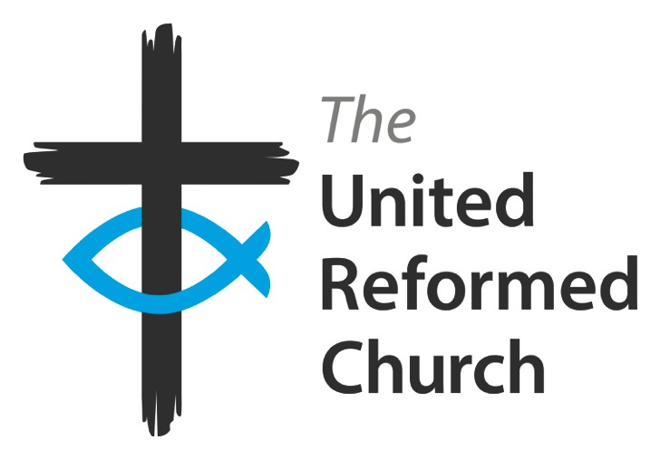
The United Reformed Church (South Western Synod)
Incorporated ‘The Synod Trust’

HIRING CHECKLIST

Church:

Prepared by:

Date:

Please send this completed checklist to the Synod Trust, by post or email (property@urcsouthwest.org.uk), with your church’s certified copy of your Church Meeting resolution accepting the terms of the Trust’s ‘delegation resolution’.
This information will help the Synod Trust arrange the delegation of power to hire premises to your church Minister and Elders.

A. Safeguarding and Safety
1. Has your church Safeguarding Policy been prepared or reviewed in the last 12 months?

Yes/No

2. Does your hiring agreement contain the relevant wording regarding hirers following safeguarding procedures? Yes/no

3. Have you prepared a Fire Emergency Plan and Risk Assessment for your premises? Yes/No

4. Have you prepared a Health and Safety policy and/or accident Risk Assessment for your premises ? Yes/No

[You will need to be able to answer yes to these questions before the Trust can delegate hiring powers to your church]

B. Your approach to preparing your church’s hiring agreement
1. Will you be using a ‘paper’ approach to obtaining the hirer’s consent to the conditions?

Yes/No
2. Will you be using an ‘email’ approach to obtaining the hirer’s consent to the conditions?

Yes/No
3. Will you be using an ‘online booking system’ to obtain the hirer’s consent to the conditions? [If so you will need to show the Synod Trust how this incorporates all elements of the standard documentation]

Yes/No
4. Do you intend to add your own additional ‘Rules and Regulations’ to supplement the standard agreement? Please specify for approval by the Synod Trust.

Yes/No

C. Situations where a standard hiring agreement is not suitable and which therefore require Trust-prepared leases, licences, or other legal agreements [please refer to the Handbook for Hiring,letting & leasing Church Premises for more details]

1. If you have any current leases, licences (including car park licences), tenancies at will or other such legal agreements with hirers, please give details including the hirer’s name and the dates of the agreement [these agreements may require review and updating]:

2. Please list any other hirers for whom a ‘licence to occupy’ will need to be prepared, including:
- any Ofsted registered child-care provider,
- any regular hirer who will use the premises on 5 or more days per week
- any regular hirer who will use the premises for more than 15 hours per week
- any hirer who wishes to have an agreement extending beyond 6 months

3. Do you need a car park licence preparing for spaces where the Trust has not already issued a licence?

Yes/No

If so, please give brief details:

4. Do you need an agreement for covering any exclusive use of storage facilities?

Yes/No

If so, please give brief details:

5. If you wish to offer a tenancy for exclusive use of part of the premises, please give brief details so that the need for a lease may be considered:

6. If your premises include any residential accommodation (including for a caretaker or worker, but not a manse) please give details and supply a copy of the agreement used for this:

